**C64 PSU Combi Rev. 2**

**Module Description**

Table of Contents

1. Introduction 2

2. External DC Power Supply 3

3. The Expansion Module 3

4. Connectors 4

4.1. J1, J2 – Mains connectors 4

4.2. J3 – DC-PSU 5

4.3. J4 – C64 Output 5

4.4. J5 – 1541-II or Amiga Output 5

4.4.1. Version 1541-II 5

4.4.2. Version Amiga 5

4.5. J6 – 1541-II Output 6

4.6. J10 - +5V For Barrel Connector 6

4.7. J15 – Panel Volt-Meter (+5V) 6

4.8. J16 – Panel Volt-Meter (+12V) 6

4.9. Expansion connector – J19 7

4.10. Power LED – J8 7

4.11. PE connection 7

5. Fuses 7

6. Wiring 8

6.1. Annotations 8

6.2. Wires 11

6.2.1. Lengths 11

6.2.2. W100 11

6.2.3. W200 11

6.2.4. W300 12

6.2.5. W400 12

6.2.6. W500 13

6.2.7. W600 14

6.2.8. W700 15

6.2.9. W800 16

6.2.10. W900 16

7. Metal parts 17

8. Assembly 19

8.1. STEP 1 – Copy holes 19

8.2. STEP 2 – Connecting W300 and W500 to DC PSU 19

8.3. STEP 3 – W400, W600, W700 and W800 at Back Panel 21

8.4. STEP 4 – Appliance connector and mains switch 22

8.5. STEP 5 – Install W100 and W200 23

8.6. STEP 6 - Installing the DC PSU 23

8.7. STEP 7 - Installing the PCB 24

8.8. STEP 8 – Connect the Cables 25

9. Testing 25

10. Picture gallery 26

11. Further Thoughts 30

12. Revision History 30

12.1. Rev. 0 30

12.2. Rev. 0 → Rev. 1 30

12.3. Rev. 1 → Rev. 2 30

# Introduction

The C64 combi PSU is a power supply board for the Commodore C64 and up to two floppy disk drives 1541-II. Depending on the used external DC-power supply, one of the 1541 connectors can be used for a Commodore AMIGA.

This board connects to mains and it contains a 9V transformer, which provides the 9VAC for the C64. For the DC-Voltages, a variety of power supply modules can be connected externally.

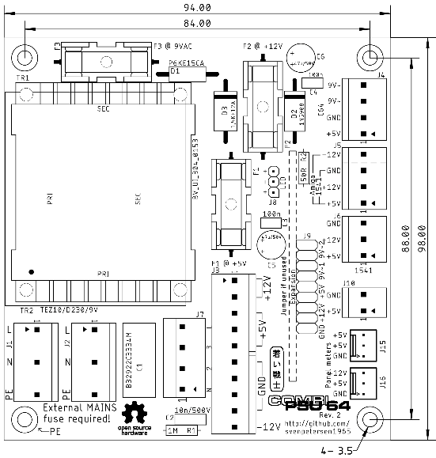

Figure 1: Measures of the board

The board allows a number of alternative placements and optional components:

* There are footprints for two different transformers, a chassis mount transformer can be connected via four spade connectors
* Two panel meters for +5V and +12V can be connected, if not wanted, the connectors do not need to be populated.
* An extension module can be connected, which can measure or control the output voltages
* One connector can provide voltages for either a 1541-II disk drive or an Amiga

# External DC Power Supply

The external power supply should either have the output voltages +5V (≥3.5A), +12 V (≥1A) for one C64 and two 1541-II floppy disk drives or +5V (≥5A), +12V (≥2A), -12V (≥0.1A). The traces on the PCB are calculated for 4A (+12V, 9VAC), 6A (+5V) and 2.5A (-12V). The fuses have to be picked according to the maximum current of the output voltages and the copper traces.

For best operation (due to voltage drops on the PBC and the cables), it is recommended to adjust the power supply to +5.1V to +5.2V. While adjustment, any devices must not be connected to the PSU. The other voltages need to be checked. A slightly higher output on +12V is also ok.

Suggested PSUs (many other possible):

* Mean Well: RD-50A (+5V @ 6A, +12V @ 2A) (e.g. Mouser: €15.34)
* Mean Well: RT-65B (+5V @ 5A, [+12V @ 2.8A](mailto:+12V%20@%202.8A), -12V @ 0.5A) (e.g. Mouser: 17,43€)

Be aware that the DC PSU has a soft start feature. The delay between the switch and +5V and +12V on is up to 1 second. The transformer does not switch on with delay. This means, the 9VAC comes first.

**It is advised to switch on the PSU and then the connected devices.** Switching on the devices first did not harm the devices, they worked properly, but it is not the recommended way.

# The Expansion Module

For monitoring or controlling the output voltages of the C64 PSU Combi, an optional Expansion module can be connected to J9. The connector has input and output pins for the 9VAC, the +12V and the +5V. It also offers two GND pins.

In case the Expansion Module is not installed, the pins, mentioned before, have to be bridged with jumpers (rated 3A).

A maximum height of 20mm is assumed for the expansion module.

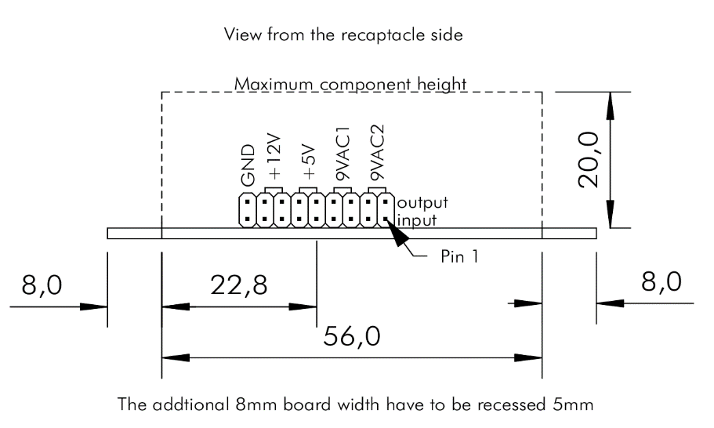

Figure 2: Dimensions of the Expansion Module

The maximum dimensions of the Expansion Module are shown in Figure 2. The length of the module depends on the enclosure of the power supply and the standoffs for the PCB.

Any voltage, that is unused on the expansion module should be bridged (80mil trace!) on there. The same is valid for voltages, which do not have a current measurement or any switch like function.

To prevent slipping off the connectors, the Expansion Module needs to be secured with silicon glue (which is reversible) after testing.

# Connectors

## J1, J2 – Mains connectors

* Molex KK 396 Header, Vertical, Friction Lock, 5 Circuits, Tin (Sn) Plating (Pin 2 and pin 4 removed): P/N 0026604050
* KK 3.96mm Crimp Terminal Housing, Friction Ramp, 5 Circuits, Natural: P/N 09503051
* KK 396 Crimp Terminal 2478, 18-24 AWG, Bag, Brass Tin (Sn): P/N 08500106.

|  |  |
| --- | --- |
| Pin | Signal |
| 1 | L (live/hot) |
| 3 | N (neutral) |
| 5 | PE (protective earth) |

J1 is for the mains input, J2 is branching to the external DC-PSU.

## J3 – DC-PSU

* Molex KK 396 Header, Vertical, Friction Lock, 10 Circuits, Tin (Sn) Plating:   
  P/N 0026604100
* KK 3.96mm Crimp Terminal Housing, Friction Ramp, 10 Circuits, Natural: P/N 09503101
* KK 396 Crimp Terminal 2478, 18-24 AWG, Bag, Brass Tin (Sn): P/N 08500106.

|  |  |
| --- | --- |
| Pin | Signal |
| 1 | +12V |
| 2 | +12V |
| 3 | +5V |
| 4 | +5V |
| 5 | +5V |
| 6 | GND |
| 7 | GND |
| 8 | GND |
| 9 | GND |
| 10 | -12V |

## J4 – C64 Output

* Molex KK 396 Header, Vertical, Friction Lock, 4 Circuits, Tin (Sn) Plating:   
  P/N 0026604040
* KK 3.96mm Crimp Terminal Housing, Friction Ramp, 4 Circuits, Natural: P/N 09503041
* KK 396 Crimp Terminal 2478, 18-24 AWG, Bag, Brass Tin (Sn): P/N 08500106.

|  |  |
| --- | --- |
| Pin | Signal |
| 1 | +5V |
| 2 | GND |
| 3 | 9VAC2 |
| 4 | 9VAC1 |

## J5 – 1541-II or Amiga Output

### Version 1541-II

For the **1541-II** only populate Pin 1 to 3. See J6.

### Version Amiga

* Molex KK 396 Header, Vertical, Friction Lock, 4 Circuits, Tin (Sn) Plating:   
  P/N 0026604040
* KK 3.96mm Crimp Terminal Housing, Friction Ramp, 4 Circuits, Natural: P/N 09503041
* KK 396 Crimp Terminal 2478, 18-24 AWG, Bag, Brass Tin (Sn): P/N 08500106.

|  |  |
| --- | --- |
| Pin | Signal |
| 1 | +5V |
| 2 | +12V |
| 3 | GND |
| 4 | -12V |

## J6 – 1541-II Output

* Molex KK 396 Header, Vertical, Friction Lock, 3 Circuits, Tin (Sn) Plating:   
  P/N 0026604030
* KK 3.96mm Crimp Terminal Housing, Friction Ramp, 3 Circuits, Natural: P/N 09503031
* KK 396 Crimp Terminal 2478, 18-24 AWG, Bag, Brass Tin (Sn): P/N 08500106.

|  |  |
| --- | --- |
| Pin | Signal |
| 1 | +5V |
| 2 | +12V |
| 3 | GND |

## J10 - +5V For Barrel Connector

* Molex KK 396 Header, Vertical, Friction Lock, 2 Circuits, Tin (Sn) Plating:   
  P/N 0026604020
* KK 3.96mm Crimp Terminal Housing, Friction Ramp, 2 Circuits, Natural: P/N 09503021
* KK 396 Crimp Terminal 2478, 18-24 AWG, Bag, Brass Tin (Sn): P/N 08500106.

|  |  |
| --- | --- |
| Pin | Signal |
| 1 | +5V |
| 2 | GND |

## J15 – Panel Volt-Meter (+5V)

* Molex KK 254 Wire-to-Board Header, Vertical, with Friction Lock, 3 Circuits, Tin (Sn) Plating: P/N 22272031
* KK 254 Crimp Housing, 3 Circuits, Natural: P/N 22-01-3037
* KK 254 Crimp Terminal, 22-30 AWG, Bag, Hot Tin (Sn) Dip Plating: P/N 08500114

|  |  |
| --- | --- |
| Pin | Signal |
| 1 | GND |
| 2 | +5V (supply) |
| 3 | +5V (measurement) |

## J16 – Panel Volt-Meter (+12V)

* Molex KK 254 Wire-to-Board Header, Vertical, with Friction Lock, 3 Circuits, Tin (Sn) Plating: P/N 22272031
* KK 254 Crimp Housing, 3 Circuits, Natural: P/N 22012031
* KK 254 Crimp Terminal, 22-30 AWG, Bag, Hot Tin (Sn) Dip Plating: P/N 08500114

|  |  |
| --- | --- |
| Pin | Signal |
| 1 | GND |
| 2 | +5V (supply) |
| 3 | +12V (measurement) |

## Expansion connector – J19

* Pin header, 2 x 9 circuits, 2.54mm pitch (0.1”)
* Jumper from input to output if not used (jumpers rated 3A)

|  |  |  |  |
| --- | --- | --- | --- |
| Signal | Pin | Pin | Signal |
| Input 9VAC (2) | 1 | 2 | Output 9VAC (2) |
| Input 9VAC (2) | 3 | 4 | Output 9VAC (2) |
| Input 9VAC (1) | 5 | 6 | Output 9VAC (1) |
| Input 9VAC (1) | 7 | 8 | Output 9VAC (1) |
| Input +5V | 9 | 10 | Output +5V |
| Input +5V | 11 | 12 | Output +5V |
| Input +12V | 13 | 14 | Output +12V |
| Input +12V | 15 | 16 | Output +12V |
| GND | 17 | 18 | GND |

If no expansion module is in place, the inputs have to be connected to the corresponding outputs with jumpers (2.54mm, 0.1”).

## Power LED – J8

* Pin header, 1x3 circuits, 2.54mm (0.1”) pitch
* Crimp housing: Dupont crimp housing
* Dupont crimp terminals

It is possible to use a widely available (Ebay, AliExpress etc.) Dupont cable, which can be cut and soldered to the LED.

|  |  |
| --- | --- |
| Pin | Signal |
| 1 | LED + |
| 2 | LED - |
| 3 | LED + |

## PE connection

The marked mounting hole is connected to PE.

# Fuses

Since the rating of the fuses depend on the external power supply, that is used, there can only be recommendations. The copper tracks on the PCB are rated for 4A (9VAC, +12V) and 6A (+5V). These are the **absolute maximum ratings** for the fuses. Do not exceed this, even if the power supply is rated higher!

|  |  |  |
| --- | --- | --- |
| Fuse | Voltage | Recommendation |
| F1 | +5V | 3A |
| F2 | +12V | 1.6A |
| F3 | 9VAC | 1.6A |
| Mains |  | 0.5A slow bow |

The ratings above are conservative. For powering an Amiga, higher ratings are required. Refer to the ratings of the original power supply.

The (external) mains fuse depends on the inrush current of the external power supply. The value has to be determined carefully. In case this fuse fails, the rating has to be increased.

# Wiring

## Annotations

This device is connected to mains. Mains voltage is potentially lethal. High currents, that can occur in this device can cause fire hazards. Do not carry out this work, if you are not trained!

Up to four sorts of crimp contacts are required for installing this device:

* FastOn Flat connectors 6.3 x 0.8 (isolated, red) for mains connector/switch
* Fork shaped/ring cable lugs (semi isolated, red) for the power supply
* Molex SPOX/KK 3.96
* Molex SPOX/KK 5.08
* Molex KK2.54

The crimp tools for the first two types are cheap. A tool capable of isolated crimps is required. At least the 2nd type has to be crimped, while the first type can be soldered (do not forget the shrinkable sleeve). Crimping is the recommended method.

The latter two contact types can be crimped with the Engineer PA-20 or (probably) the IWISS IWS-2820M. The cables can also be directly solder into the pads of the connectors. This is possible, but not recommended.

A quality control of every crimp is required. That means, the flat connectors and the ring cable lugs must not fall off the cable when pulling it.

It is definitely recommended to order more than just the required amount of each crimp connector/terminal. It is not unlikely, that some crimps don’t work out, depending on the experience with this production method.

The installation of the PSU in a metal enclosure requires connection to PE of all metal parts of this enclosure. These connections need to be proved (at least with a multimeter) after finishing the assembly. One mounting hole of the PCB is connected to the PE of the installation. This is marked “← PE”. Chopper disks are recommended to attain a good connection.

Many metal cases can be used as suitable enclosure for this PSU.

The Hammond 1411P was used for one version of the PSU Combi. It is quite compact (127mm x 152mm x 102mm) and fits the RD-50A. The price is about 16€ (tme.eu/2020).

Another case is the TEKO 384 (203mm x 160mm x 70mm). It is less high, both, the external PSU and the PCB can be mounted flat, which might be easier. The price is about 22€ (reichelt.de/2020).

In case, the power cables should stay connected to this PSU, strain reliefs are required. The recommended way is a DIN-jack on the back panel of the power supply and extra cables to have as few cables in the installation as possible.

Table 2 and Table 1 show the power jacks of the C64 and the 1541-II. The view is on the particular contact side. This is identical with the view on the solder side of the respective DIN plugs. The cables soldered to the din plugs should be 0.5mm²/AWG21. It is possible to use 0.75mm²/AWG20 wires, but this might require to clip off some of the wire strands, since the solder cups of the DIN plugs are usually not capable of accepting a wire of this diameter.

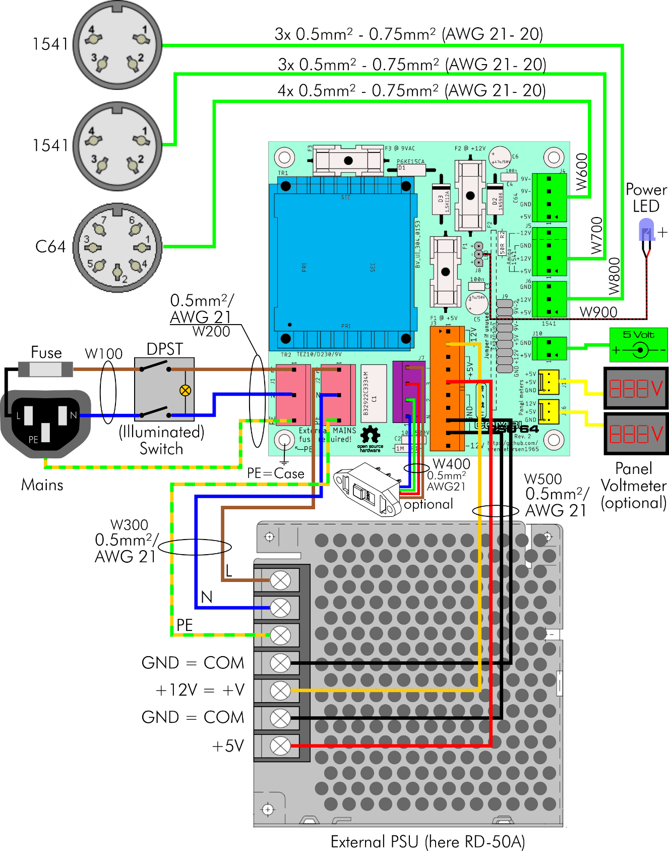

Figure 3: Wiring of the CombiPSU64

Table 1: Power jack of the 1541-II

Table 2 and Table 1 show the power jacks of the C64 and the 1541-II. The view is on the particular contact side. This is identical with the view on the solder side of the respective DIN plugs. The cables soldered to the din plugs should be 0.5mm²/AWG21. It is possible to use 0.75mm²/AWG20 wires, but this might require to clip off some of the wire strands, since the solder cups of the DIN plugs are usually not capable of accepting a wire of this diameter.

## Wires

### Lengths

The lengths of the wires are calculated for the Hammond 1411P case. They may differ for other configurations.

### W100

These wires connect the appliance connector to the switch.

|  |  |
| --- | --- |
| Qty | Item |
| 4 | FastOn 6.3x0.8, red, ISO |
| 12cm | Wire: 0.5mm²/AWG21, blue |
| 12cm | Wire: 0.5mm²/AWG21, brown |

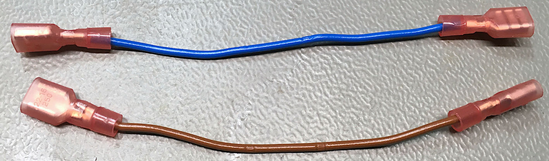

Figure : W100

### W200

The wire connects the PCB (J1) to the mains switch. The (green/yellow) PE wire is connected to the PE pin of the appliance connector.

|  |  |
| --- | --- |
| Qty | Item |
| 3 | FastOn 6.3x0.8, red, ISO |
| 11cm | Wire: 0.5mm²/AWG21, blue |
| 11cm | Wire: 0.5mm²/AWG21, brown |
| 15cm | Wire: 0.5mm²/AWG21, green/yellow |
| 1 | Crimp housing: Molex P/N 09503051 |
| 3 | Crimp terminals: Molex P/N 08500106 |

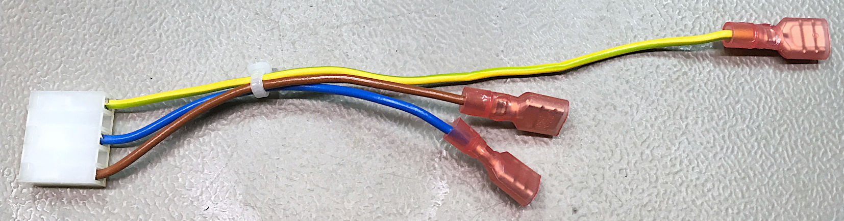

Figure : W200

### W300

W300 connects the PBC (J2) to the external DC power supply.

|  |  |
| --- | --- |
| Qty | Item |
| 3 | Fork connectors for M3, red, iso |
| 19cm | Wire: 0.5mm²/AWG21, blue |
| 19cm | Wire: 0.5mm²/AWG21, brown |
| 19cm | Wire: 0.5mm²/AWG21, green/yellow |
| 1 | Crimp housing: Molex P/N 09503051 |
| 3 | Crimp terminals: Molex P/N 08500106 |

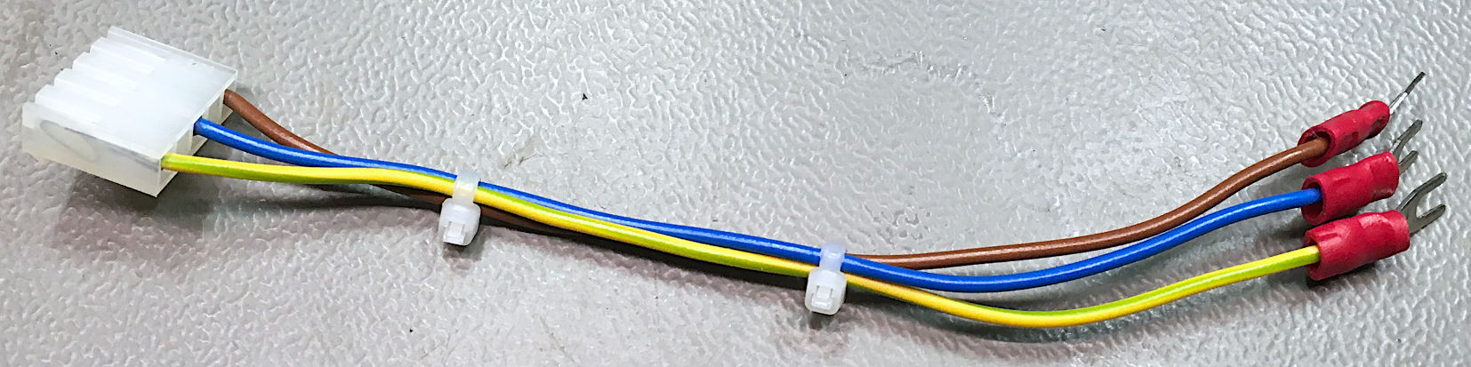

Figure : W300

### W400

W400 is only required, in case the 230V/115V version of the PSU combi is built. It is the mains voltage selector switch.

This switch cable has to be built with great care. Messing up might destroy the transformer. The secondary coils are connected in series for 230V and in parallel for 115V. The orientation of the coils is important. Figure 9 shows the orientation of the switch. The yellow cable is in the position of the slider, when 230V is selected.

TEKO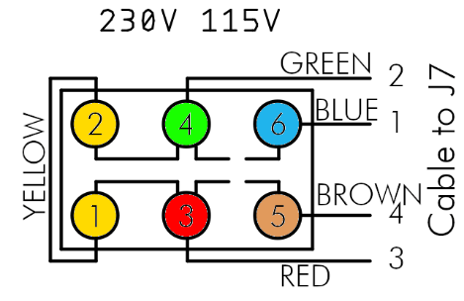

Figure 7: Mains voltage selector switch schematics

|  |  |
| --- | --- |
| Qty | Item |
| 1 | Switch: Bulgin T22205B436B |
| 14cm | Wire: 0.5mm²/AWG21, blue |
| 14cm | Wire: 0.5mm²/AWG21, brown |
| 14cm | Wire: 0.5mm²/AWG21, green |
| 14cm | Wire: 0.5mm²/AWG21, red |
| 6cm | Wire: 0.5mm²/AWG21, yellow |
| 9cm | Shrinkable sleeve 3.2/1.6 |
| 1 | Crimp housing: Molex P/N 10013046 |
| 4 | Crimp terminals: Molex P/N 08701031 |

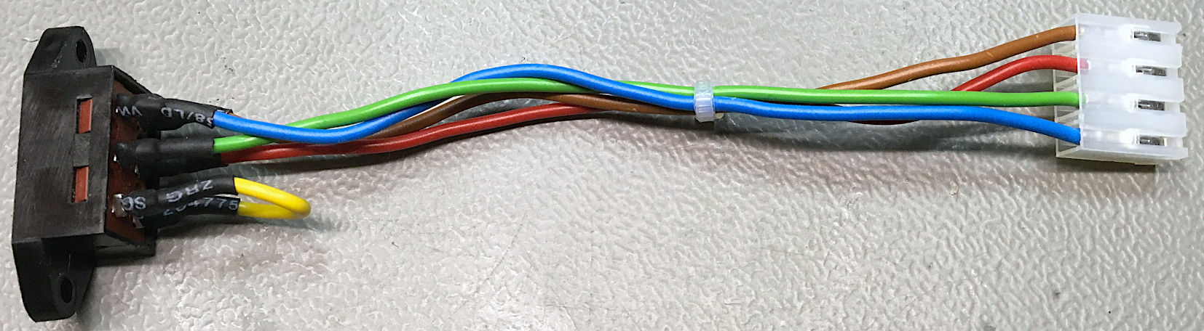

Figure : W400

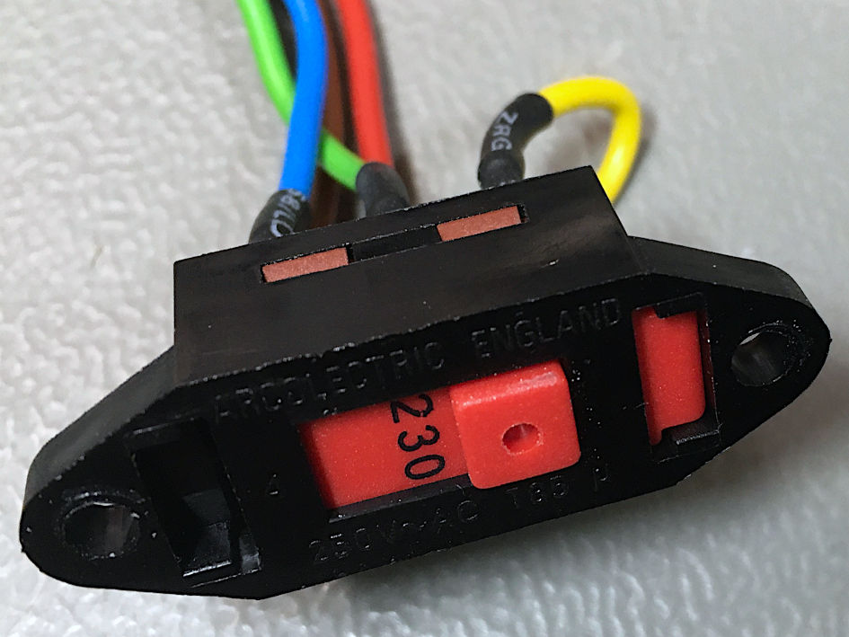

Figure 9: W400 detail

### W500

W500 connected the PCB (J3) to the output of the external DC power supply. In case you use a different power supply, the pinning can vary. It is a good practice to wire as many GND wires as there are cables to the plus side of the voltages (if possible). Here, +5V and +12V are connected with one wire each, thus there are two ground wires in case of the RD-50A power supply.

|  |  |
| --- | --- |
| Qty | Item |
| 4 | Fork connectors for M3, red, iso |
| 19cm | Wire: 0.5mm²/AWG21, red |
| 19cm | Wire: 0.5mm²/AWG21, yellow |
| 38cm | Wire: 0.5mm²/AWG21, black |
| 1 | Crimp housing: Molex P/N 09503101 |
| 4 | Crimp terminals: Molex P/N 08500106 |

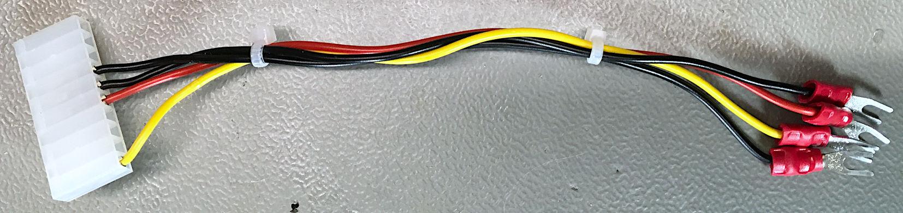

Figure 10: W500

|  |  |  |
| --- | --- | --- |
| Pin (J3) | Color | Voltage |
| 1 | yellow | +12V (+V) |
| 5 | red | +5V |
| 6 | black | GND (COM) |
| 7 | black | GND (COM) |

### W600

W600 is the cable to the output connection for the C64 (J4). Be aware, that the four-way crimp housing does not fit through the mounting hole for the DIN jack. The crimp terminals should be installed in the housing after the cable was mounted to the back panel.

|  |  |  |
| --- | --- | --- |
| C64 Power Jack | Pin | Voltage |
|  | 1 | - |
| 2 | GND |
| 3 | - |
| 4 | - |
| 5 | +5V |
| 6 | 9VAC(1) |
| 7 | 9VAC(2) |

Table 2: Power jack of the C64

|  |  |
| --- | --- |
| Qty | Item |
| 1 | 7-way DIN-Jack (panel mount) |
| 25cm | Wire: 0.5mm²/AWG21, red |
| 25cm | Wire: 0.5mm²/AWG21, black |
| 50cm | Wire: 0.5mm²/AWG21, green |
| 6cm | Shrinkable sleeve 3.2/1.6 |
| 1 | Crimp housing: Molex P/N 09503041 |
| 4 | Crimp terminals: Molex P/N 08500106 |

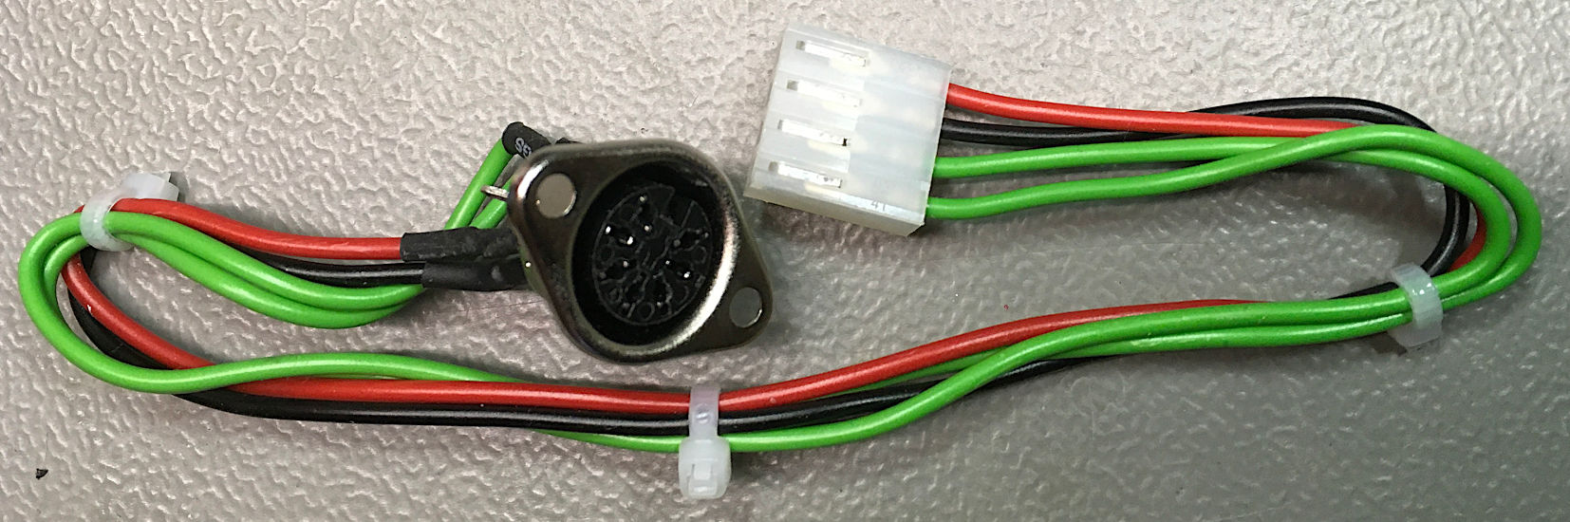

Figure 11: W600

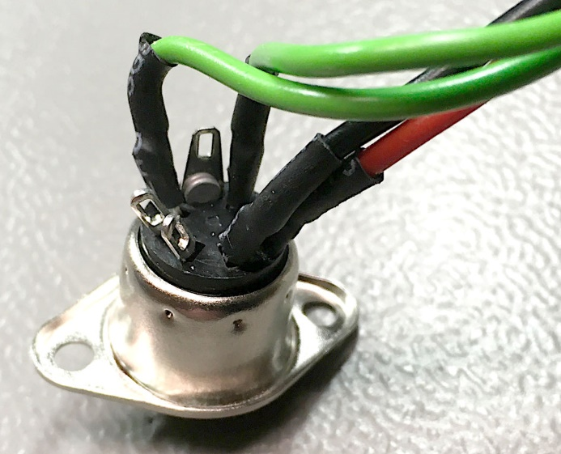

Figure 12: W600 (DIN jack)

|  |  |  |  |
| --- | --- | --- | --- |
| Pin (J4) | Color | Voltage | DIN Jack |
| 1 | red | +5V | 5 |
| 2 | black | GND | 2 |
| 3 | green | 9VAC(1) | 6 |
| 4 | green | 9VAC(2) | 7 |

### W700

W700 connects the panel mount DIN-Jack for the first 1541-II to the PCB (J5).

|  |  |  |
| --- | --- | --- |
| 1541 Power Jack | Pin | Voltage |
|  | 1 | +5V |
| 2 | GND |
| 3 | - |
| 4 | +12V |

Table 3: Power jack of the 1541-II

|  |  |
| --- | --- |
| Qty | Item |
| 1 | 4-way DIN-Jack (panel mount) |
| 35cm | Wire: 0.5mm²/AWG21, red |
| 35cm | Wire: 0.5mm²/AWG21, black |
| 35cm | Wire: 0.5mm²/AWG21, yellow |
| 5cm | Shrinkable sleeve 3.2/1.6 |
| 1 | Crimp housing: Molex P/N 09503031 |
| 3 | Crimp terminals: Molex P/N 08500106 |

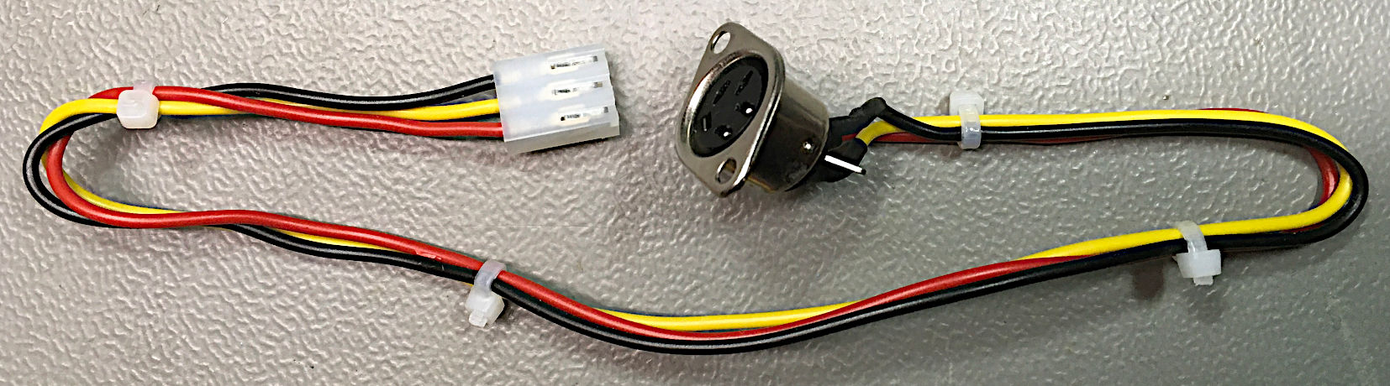

Figure 13: W700

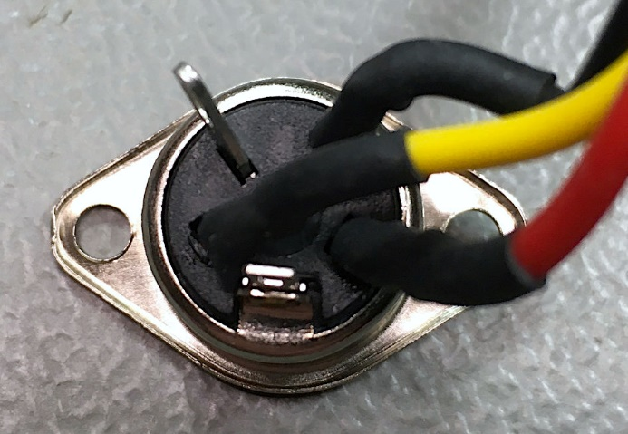

Figure 14: W700 (DIN jack)

|  |  |  |  |
| --- | --- | --- | --- |
| Pin (J5) | Color | Voltage | DIN Jack |
| 1 | red | +5V | 1 |
| 2 | yellow | +12 | 4 |
| 3 | black | GND | 2 |

### W800

W800 connects the panel mount DIN-Jack for the second 1541-II to the PCB (J6). It is identical to W700, except the length.

|  |  |
| --- | --- |
| Qty | Item |
| 1 | 4-way DIN-Jack (panel mount) |
| 30cm | Wire: 0.5mm²/AWG21, red |
| 30cm | Wire: 0.5mm²/AWG21, black |
| 30cm | Wire: 0.5mm²/AWG21, yellow |
| 5cm | Shrinkable sleeve 3.2/1.6 |
| 1 | Crimp housing: Molex P/N 09503031 |
| 3 | Crimp terminals: Molex P/N 08500106 |

### W900

W900 is the power LED. It stays with the pinout of the C64 power LED. The length depends on where you want to place your power LED.

The color of the LED determines the resistor R2 on the PCB. Different colors have forward voltages VF with LEDs. For red, yellow and green, a 330Ω resistor is good, for blue and white, a 50Ω (=47Ω…51Ω) is sufficient.

|  |  |
| --- | --- |
| Qty | Item |
| 1 | LED (color of your choice) |
| 10cm | Wire: 0.25mm²/AWG24, red |
| 10cm | Wire: 0.25mm²/AWG24, black |
| 3cm | Shrinkable sleeve 2.4/1.2 |
| 1 | 3-way DuPont crimp housing |
| 2 | DuPont crimp terminals |

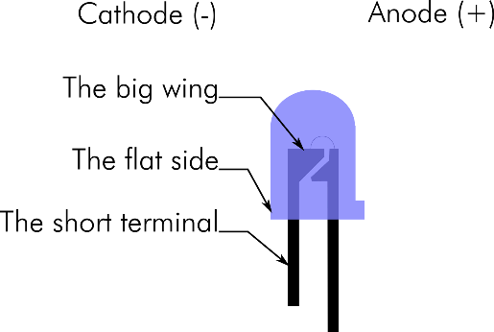

Figure 15: LED marking

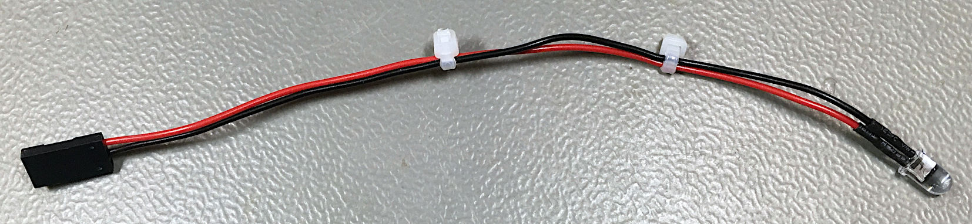

Figure : W900

|  |  |
| --- | --- |
| Pin | Signal |
| 1 | LED + |
| 2 | LED - |
| 3 | (LED +) may stay not connected |

# Metal parts

The metal parts depend on the case and the external DC power supply, which you plan to use. The Hammond 1411P case offers a very compact installation. The RD-50A DC PSU can be mounted upright and the PCB can be mounted on an aluminum panel, that is screwed to this PSU (Figure 28).

The back panel of the Hammond case needs cut outs for the appliance connector, the mains switch and the three DIN connectors for the power outputs. Optionally, a further cut out for the mains voltage selector switch is required.

The drawing of the back panel is scaled 1:1, so it can be printed out, taped to the back panel, then the centers and the corners are punched through. The outlines of the cutouts can be marked with a ruler and a scriber. All mounting holes are 3.5mm, the central cutouts for the DIN jacks have a diameter of 16mm. They can be cut with a unibit. The rectangular cutouts are done with a jigsaw.

The PCB is mounted on an aluminum plate, which holds four 15mm M3 spacers and which is screwed to the side of the RD-50A DC power supply. The third metal part is an aluminum angle profile. A drawing of the plate and the profile is provided in this documentation. It can be printed out and used as a template, as well.

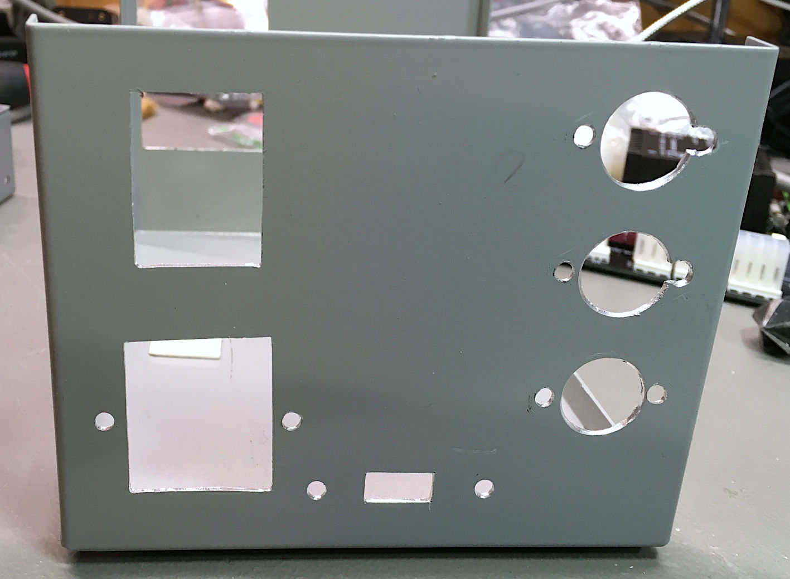

Figure 17: The back panel of the Hammond 1411P case

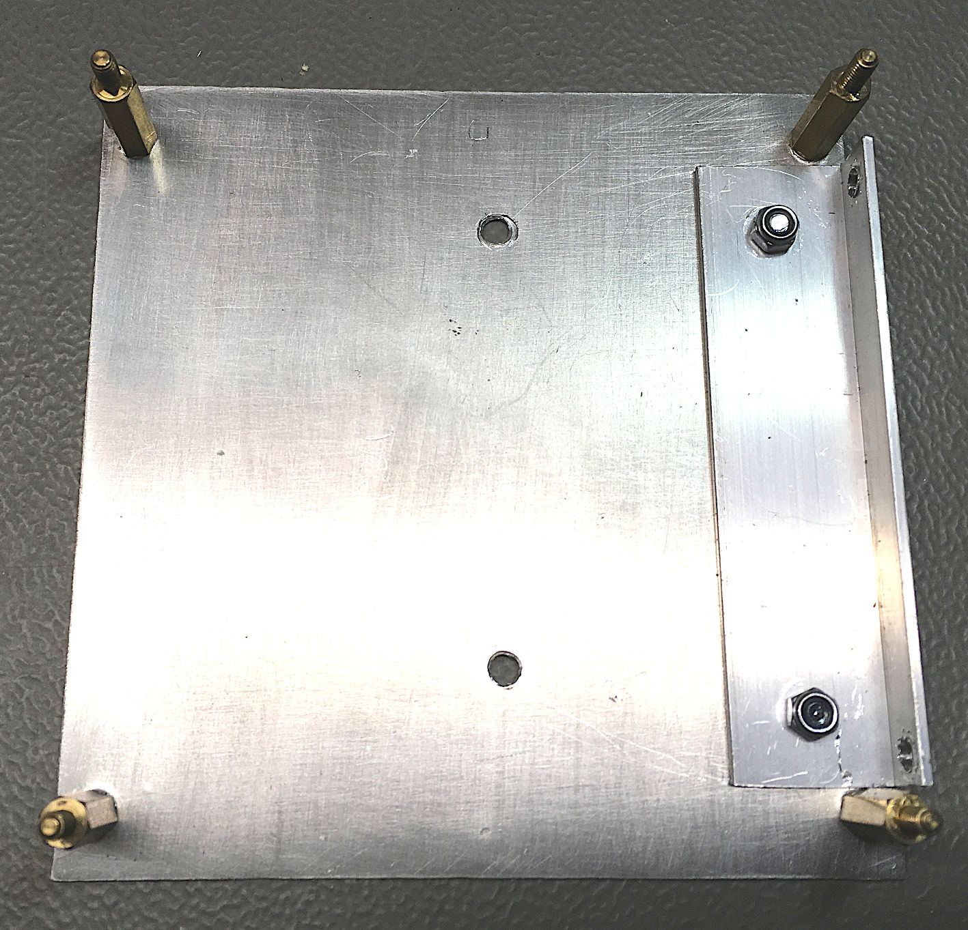

Figure 18: Mounting plate with angle profile (viewed from the PCB side)

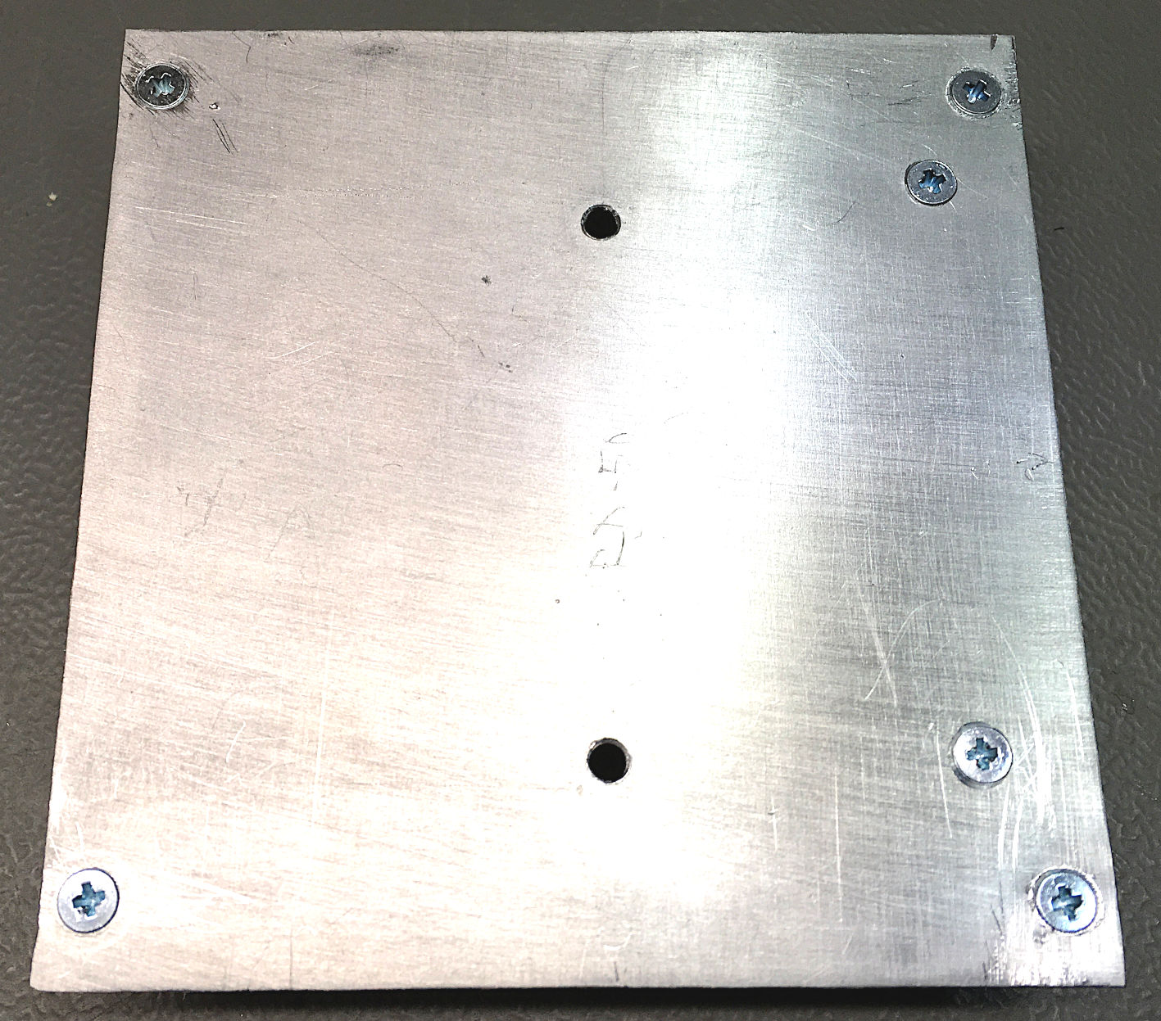

Figure 19: Mounting plate (viewed from the bottom side)

The spacers (M3, 15mm, male-female) are screwed to the mounting plate with countersunk M3x8 screws to provide a flat surface for the DC power supply.

Required screws:

* 6 ea. M3x10, countersunk
* 2 ea. M3 nut
* 2 ea. M3 toothed washer for the mounting angle
* 4 ea. M3/15mm spacer (male/female)

Drill a hole for the **power LED** (in the front panel), in case you desire it. For a 5mm LED with mounting clip, a 6.5mm drill is required.

# Assembly

## STEP 1 – Copy holes

First, the mounting plate is mounted on the RD-50A DC PSU. The DC PSU is then mounted inside the case. The purpose is to copy the drills of the angle profile to the case. The holes are marked, the PSU is unmounted again and the holes are drilled. Use M3x6 screws for holding the PSU.

## STEP 2 – Connecting W300 and W500 to DC PSU

The mains cable W300 and the output cable W500 are connected to the DC PSU (Figure 20).

|  |  |  |
| --- | --- | --- |
| Cable | Color | Terminal |
| W300 | brown | L |
| blue | N |
| Yellow/green | PE (symbol) |
| W500 | black | COM |
| yellow | V+ |
| black | COM |
| red | +5V |

It is important to fasten the screw terminals well, because lose contacts can lead to fire and/or electric shock.

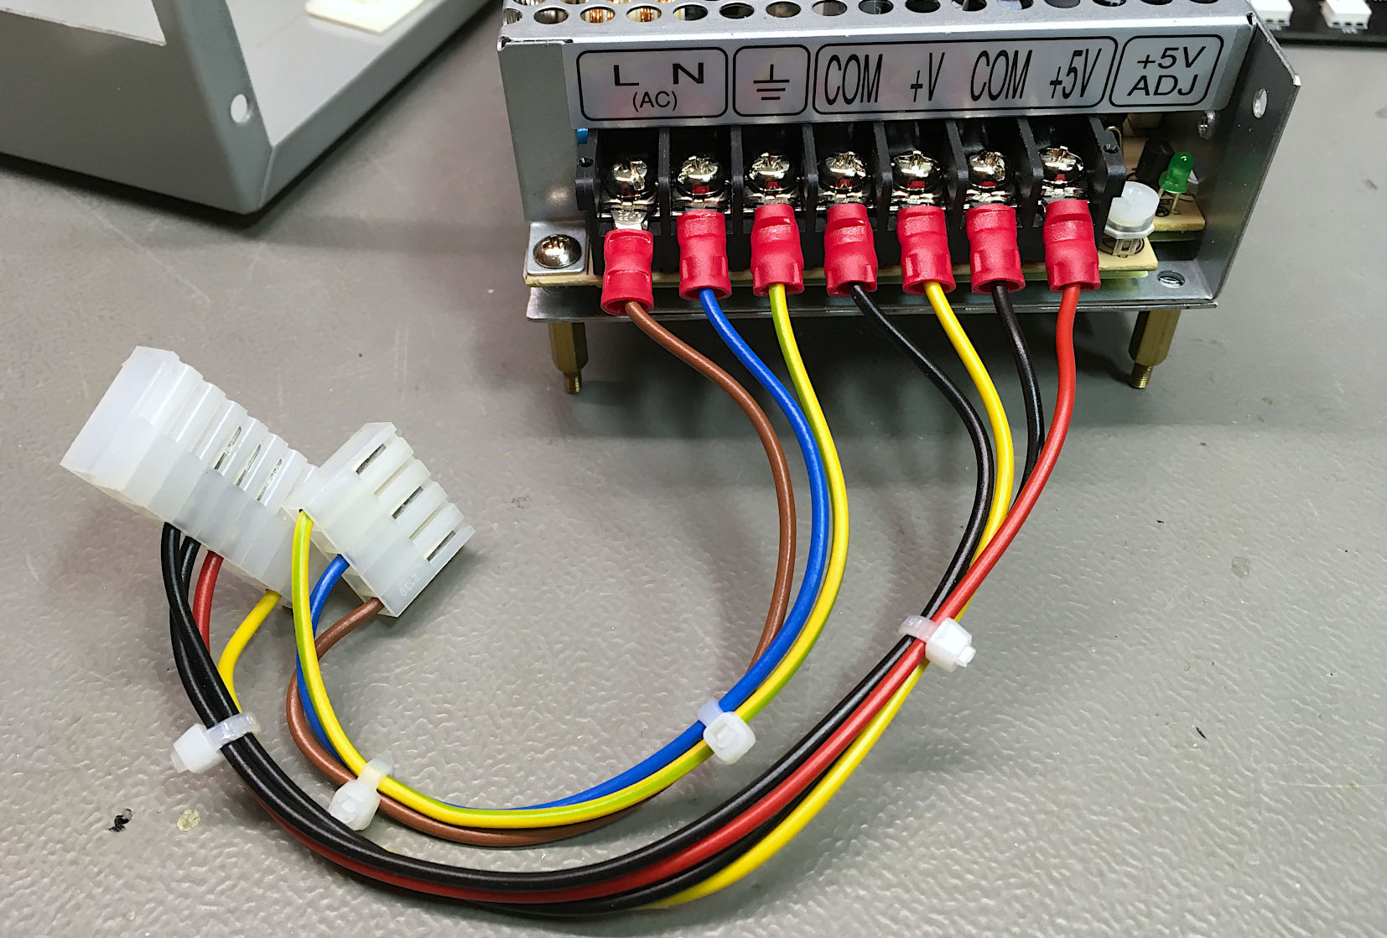

Figure 20: W300 and W500 on DC PSU RD-50A

## STEP 3 – W400, W600, W700 and W800 at Back Panel

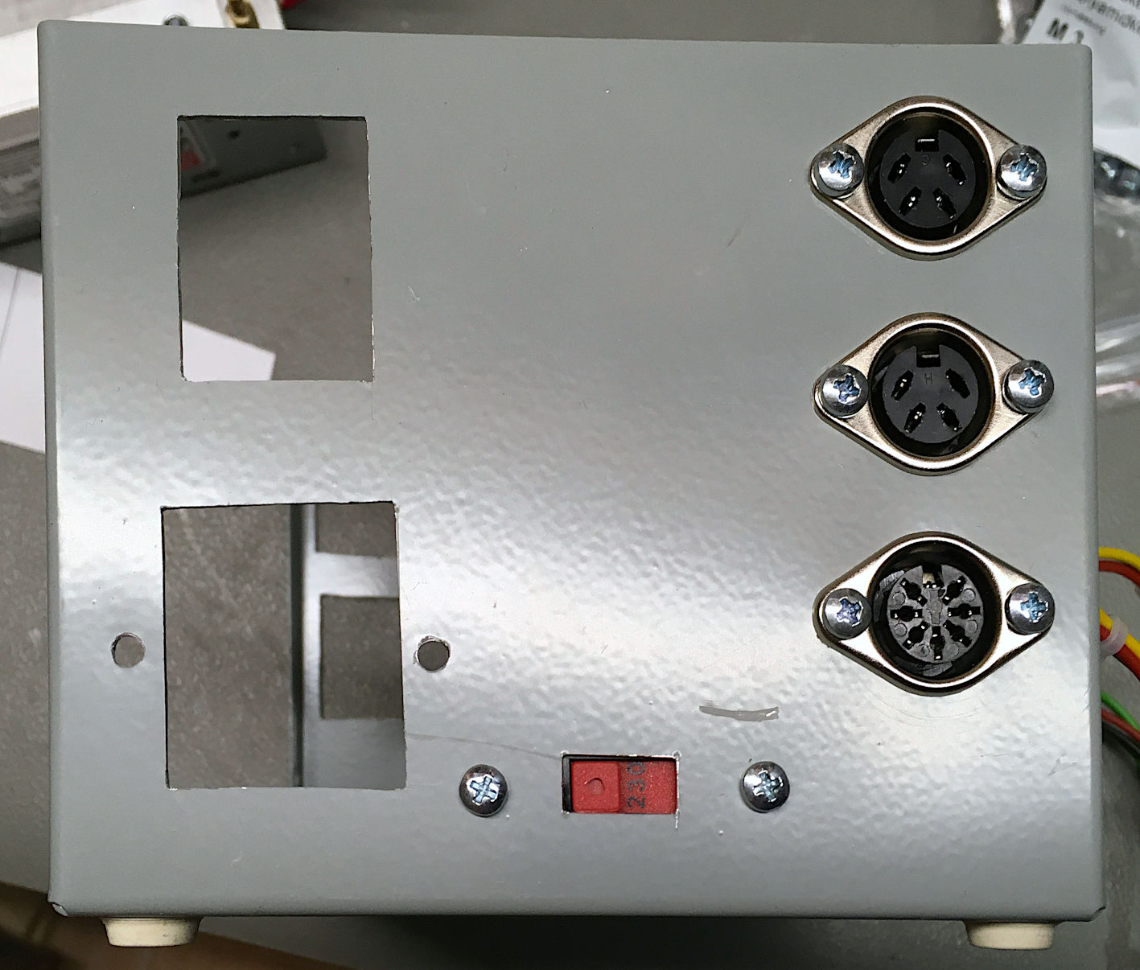

Figure 21: Output jacks and the mains voltage selector on back panel

The mains power selector switch W400 is optional and only required for the 115V/230V version. The DIN jacks should be installed with the coding notch on top for easier cable connection.

The four-way crimp housing of W600 does not fit through the 16mm mounting hole for the DIN-jack. It should be installed after the DIN-jack has been mounted.

Required screws:

* 8 ea. M3 x 10
* 8 ea. M3 (3.2mm) washer
* 8 ea. M3 nuts

## STEP 4 – Appliance connector and mains switch

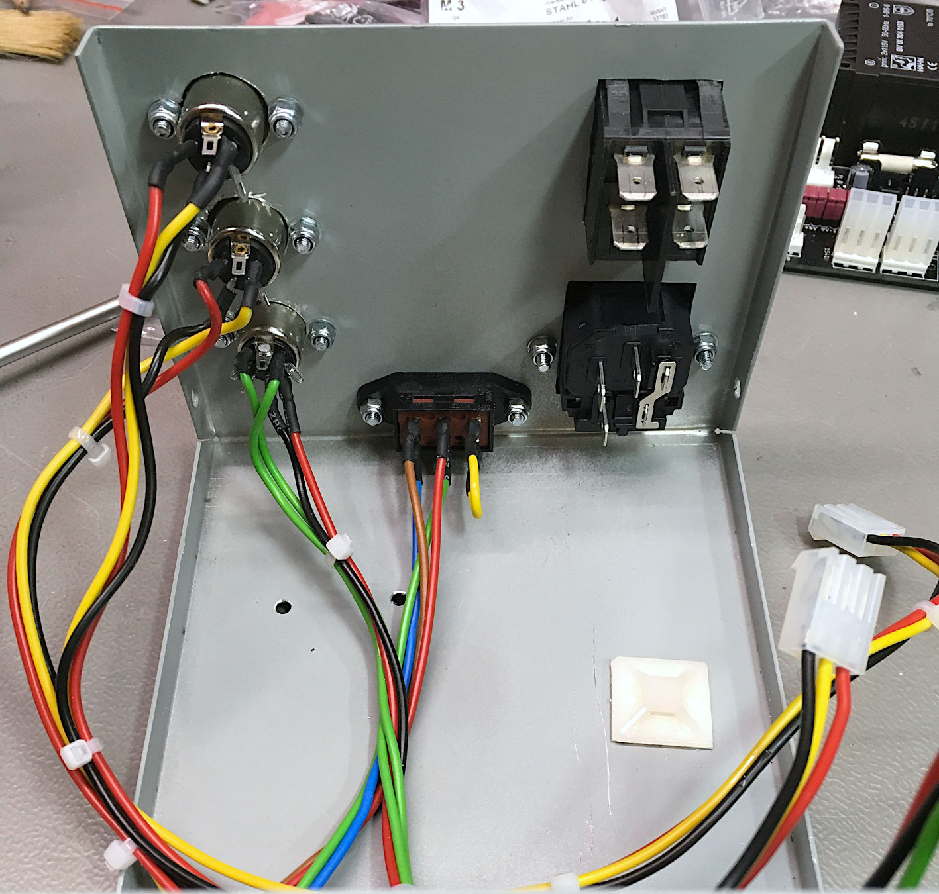

Figure 22: Back panel with all connectors installed

The appliance connector is installed before the power switch. The PE spade connector should point up.

Required screws:

* 2 ea. M3x10 counter sunk
* 2 ea. Washer (M3 = 3.2mm)
* 2 ea. M3 nuts

## STEP 5 – Install W100 and W200

W100 and W200 are the mains voltage input cables for the board. In case an illuminated mains switch is used, it is important to connect the cables (W100, Figure 4) from the appliance connector on the input side of the switch. Otherwise, the light will be on as long as the PSU is connected to the outlet. The right terminals are 1a (blue) and 2a (brown) for W100 (Figure 23).

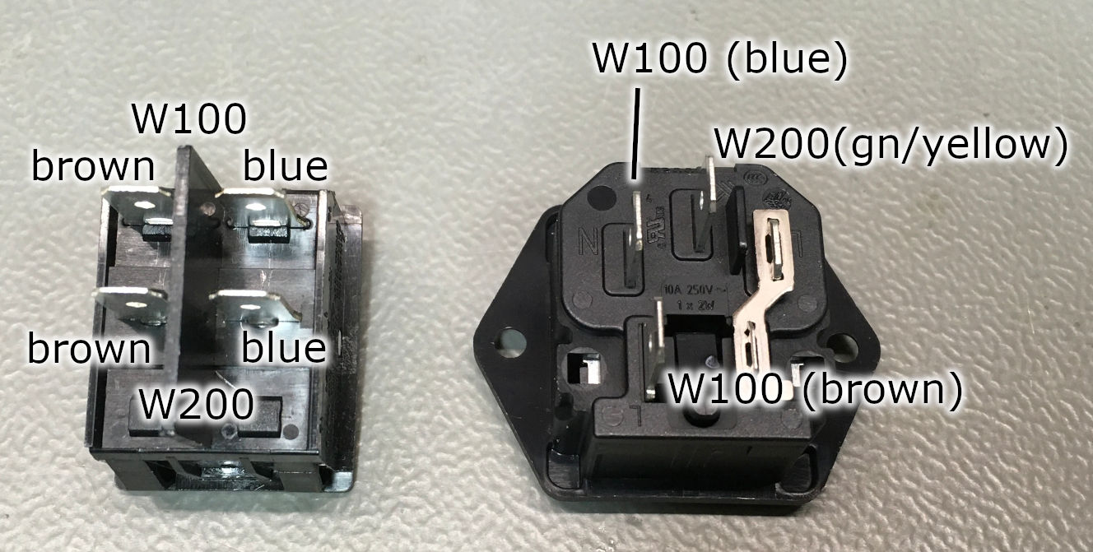

Figure 23: Terminals for connecting W100 and W200

The W100 side of the mains connector should point up.

The mains cable (W200, Figure 5) which will finally be connected to the PCB is connected to both, the switch (blue = N and brown =L) and the appliance connector (green/yellow=PE).

The (European) standard for cable colors is

|  |  |
| --- | --- |
| Potential | Color |
| L(ive) = hot | brown |
| N(eutral) | blue |
| PE (protective earth) | Green/yellow |

It is now time to install the fuse (5x20mm, 0.5A slow blow).

## STEP 6 - Installing the DC PSU

Required screws:

* 2 ea. M3x6
* 2 ea. M3x10
* 6 ea. toothed washer (M3)
* 2 nuts M3

To provide a good PE connection of the case, the mounting plate and the DC PSU, toothed washers need to be used for mounting the DC PSU in the case.

Install the DC PSU with the short screws and the toothed washers from the bottom of the case. The screw terminals are pointing towards the back panel (Figure 29). It might be required to bend the fork connectors a bit (30°) down to have enough space for all cables.

The angle profile on the mounting plate is screwed in with toothed washers non both sides with the M3x10 screws (Figure 24).

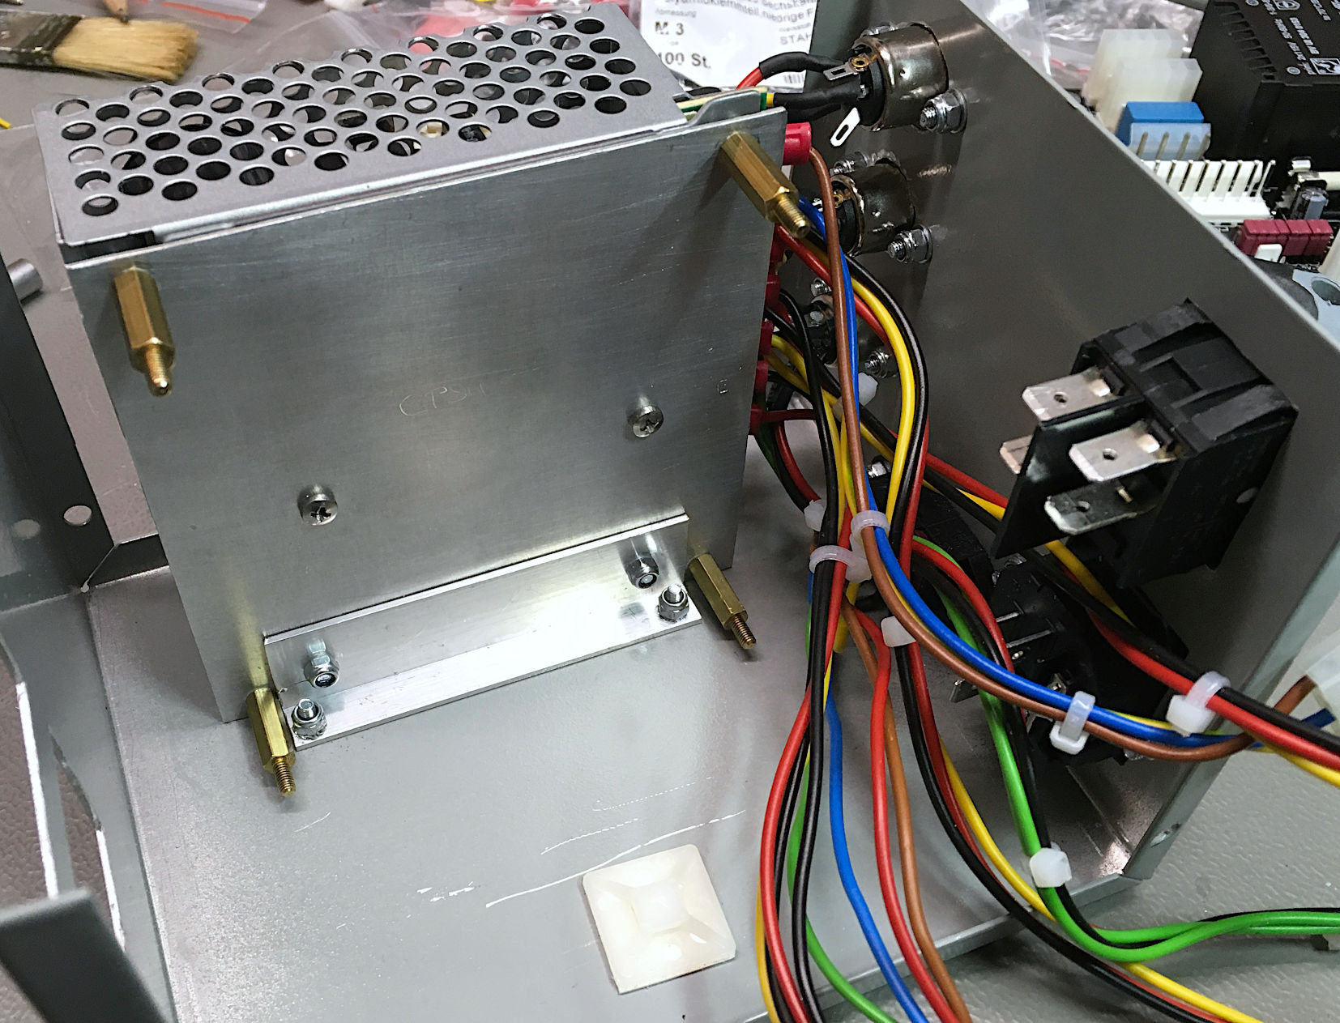

Figure 24: DC PSU installed in the case

## STEP 7 - Installing the PCB

The PCB is installed on the spacers with four M3 nuts. Use a toothed washer for the PE mounting hole (this is marked with PE).

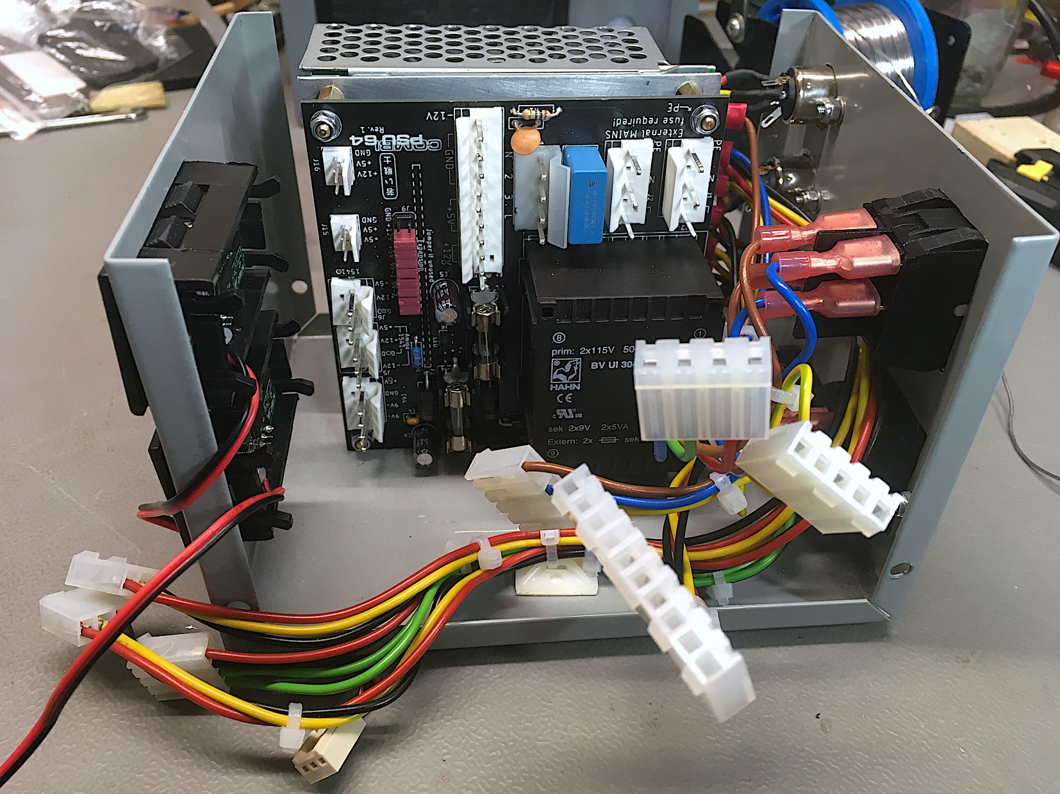

Figure 25: PCB installed

## STEP 8 – Connect the Cables

* Connect W200 (from mains switch) to J1 on the PCB
* Connect W300 (from the DC PSU) to J2 on the PCB
* Connect W400 (from voltage selector switch) to J7 on the PCB (optional for 115V/230V)
* Connect W500 (from the DC PSU) to J3 on the PCB
* Connect W600 (C64 power jack) to J4 on the PCB
* Connect W800 (lower 1541 output jack) to J5 on the PCB
* Connect W700 (upper 1541 output jack) to J6 on the PCB
* If required, connect W900 (Power LED) to J8 on the PCB, both orientations work.

J1 and J2 are in parallel, so swapping is no problem J5 and J6 are identical (as long as no AMIGA option Is selected for J5). Swapping them is no problem.

**Make sure, that J9 is completely jumpered.**

# Testing

After finishing the power supply, it is very important to test the pinning of the output jacks/cables. A mistake could fry the connected device.

First do an optical inspection.

|  |  |
| --- | --- |
| Color | Potenatial |
| Green/yellow | PE |
| Brown | L |
| Blue | N |
| Green (except W400) | 9VAC |
| Black | GND |
| Red (except W400) | +5V |
| Yellow | +12V |

The voltages are all part of the print on the PCB besides the pins of the connectors. Check it**. Then close the case.**

The ratings of the power supply depend on the used components. This way, the mains fuse requires to be determined. Values of 500mA to maybe 1A should be tested. The PSU combi does have an inrush current, so if the fuse is too weak, it will blow frequently. Nevertheless, the fuse should be as weak as possible.

**Be aware, that dealing with mains voltages is potentially lethal. Before you open the case, unplug mains!**

**If required, the +5V can be adjusted to 5.2V. This has to be accomplished while mains is switched on in an open case. Very dangerous!!! Do not connected devices while that! The voltage can be measured between COM and +5V on the DC PSU while adjustment.**

Now measure the voltages on the output jacks with a multimeter. Refer to Table 2: Power jack of the C64 and Table 3: Power jack of the 1541-II. +5V and +12V are referenced to GND. The 9VAC is only referenced to the other 9VAC pin, so it can only measured between both 9VAC pins.

The output cables (DIN connectors on both sides) should be carefully checked as well. A mistake will kill your devices!!!

If everything is ok, the PSU is ready for use.

# Picture gallery

Figure 26 shows two versions of the PSU Combi. Two different external DC power supplies are used. Left is an XPower open frame PSU, which was used, because it was “in stock”. The right power supply is the Mean Well RD-50A. The both boards are assembled with the different transformer types.

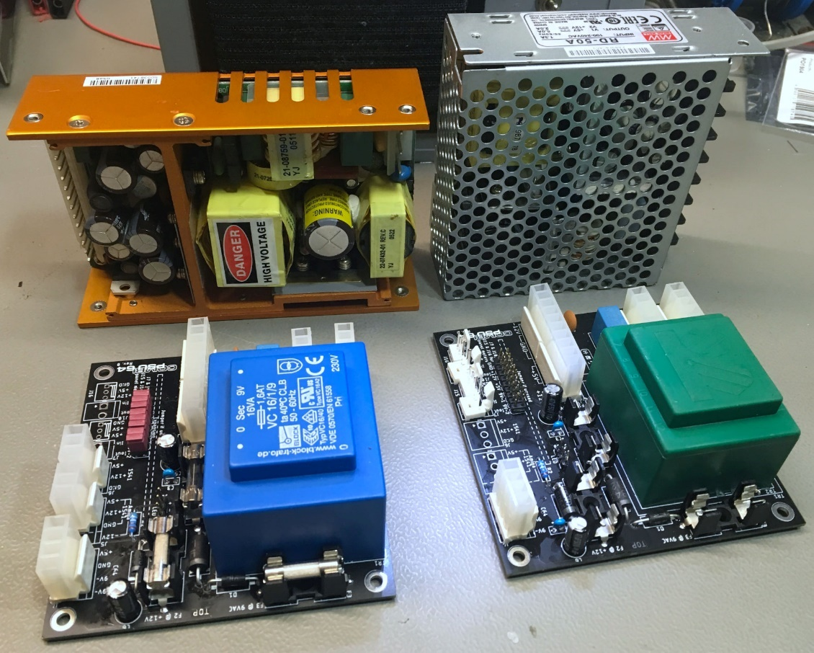

Figure 26: two versions of the PSU Combi

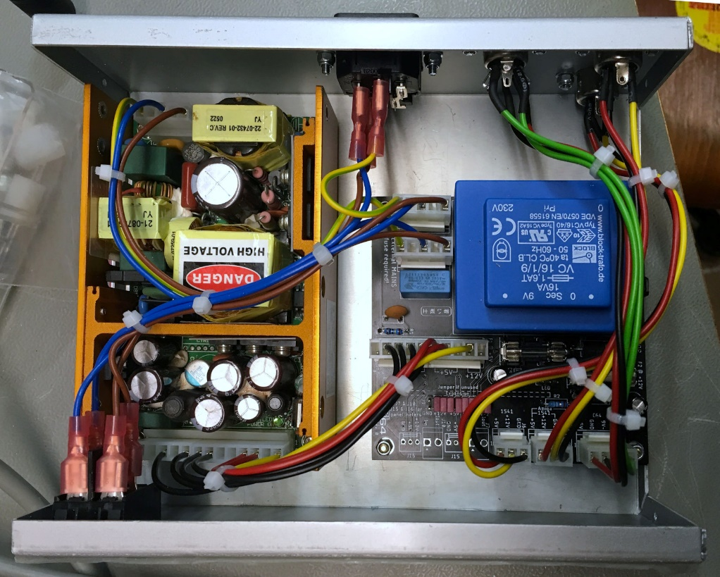

Figure 27: Finished PSU in TEKO 384 case

Figure 27 shows the finished PSU in the TEKO 384 case. The mains switch is on the front. The external PSU and the PCB fit side by side. The PSU can be mounted directly on the bottom of the case, while the PCB sits on 10mm hex bolts. The wiring of the mains and the output jacks require some space, due to the flat connectors and the bending radius of the cables.

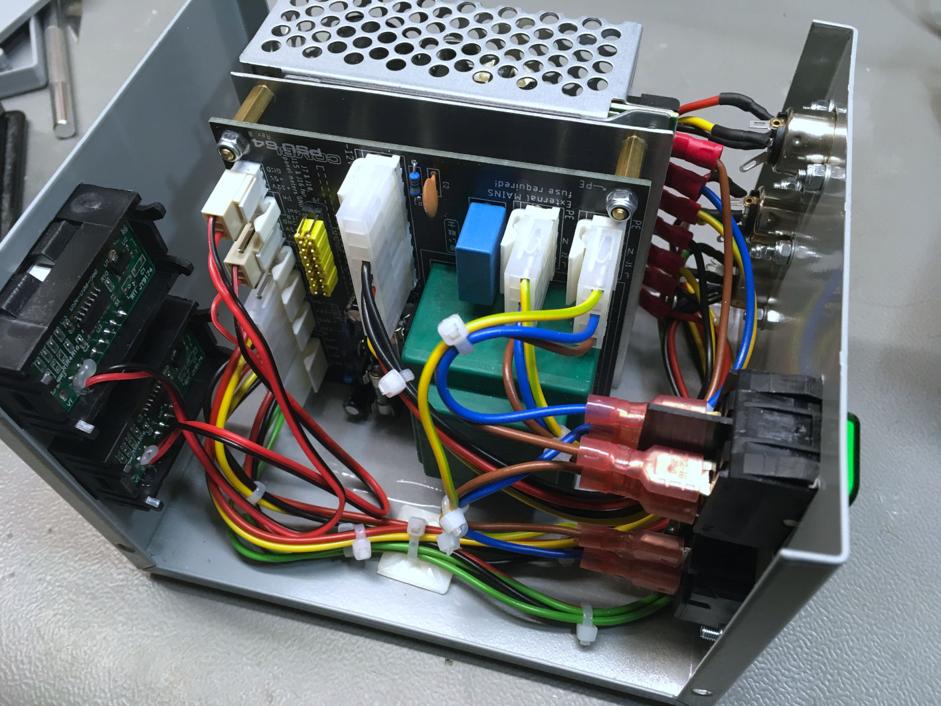

Figure 28: Finished PSU in the Hammond 1411P case

Figure 28 shows the PSU mounted inside the Hammond 1411P case. The RD-50A is mounted upright. The PCB is attached to a fitting panel, which is screwed to the bottom of the PSU and a mounting angle. This is the most compact configuration.

Cable ties and adhesive cable posts provide a clean cable routing. The mains switch is on the back.

Two panel voltmeters are installed. This is not a requirement. The voltmeter should be calibrated with a multimeter to get a useful accuracy.

Figure 29 shows the power jacks mounted to the back panel and the connection to the RD-50A with cable lugs.

Figure 30 shows the back side of the Hammond 1411P case. The mains switch is in the back, the output cables are also in the back. The output cables are detachable, which is a nice feature in case not all outputs are used permanently. In case one or two cables should stay permanently attached, strain reliefs can be mounted on the back panel.

Figure 31 shows the mounting of the RD-50A power supply and the PCB in the Hammond case. The PCB sits on a fitting panel via 15mm hex bolts. The fitting panel is screwed to the bottom of the RD-50A. A 10mm x 10mm aluminum mounting angle is screwed to the fitting panel and mounted to the bottom of the case to provide more stability.

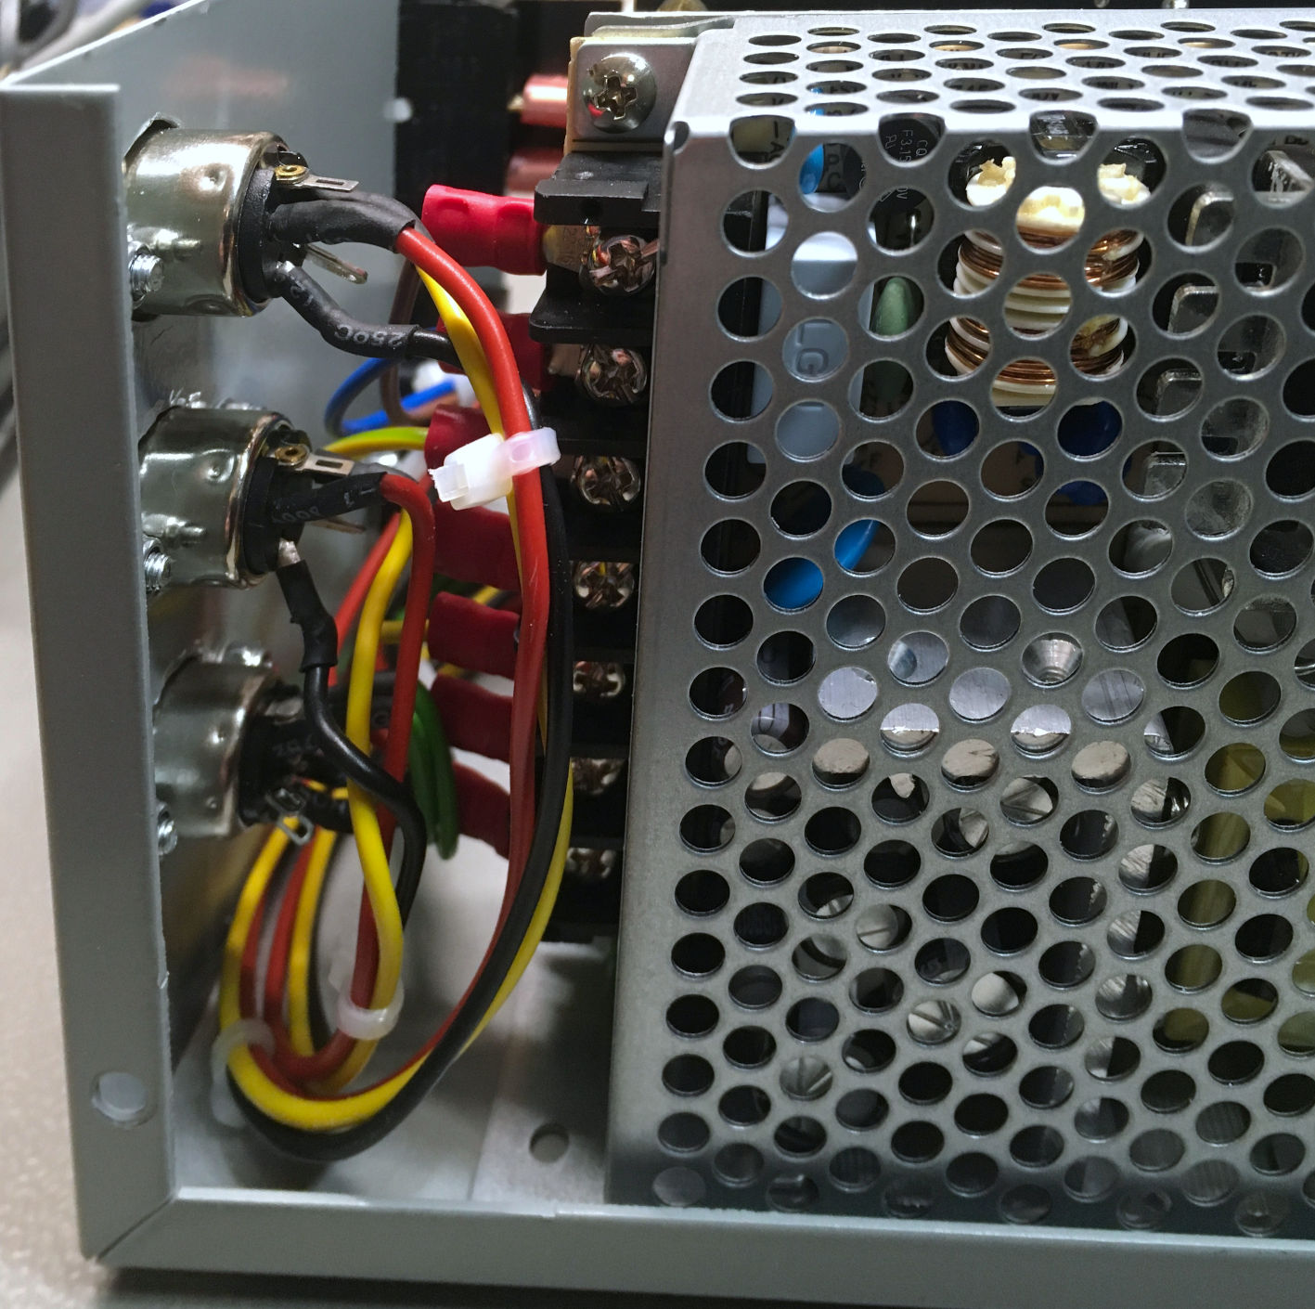

Figure 29: Power jacks and cables to the RD-50A

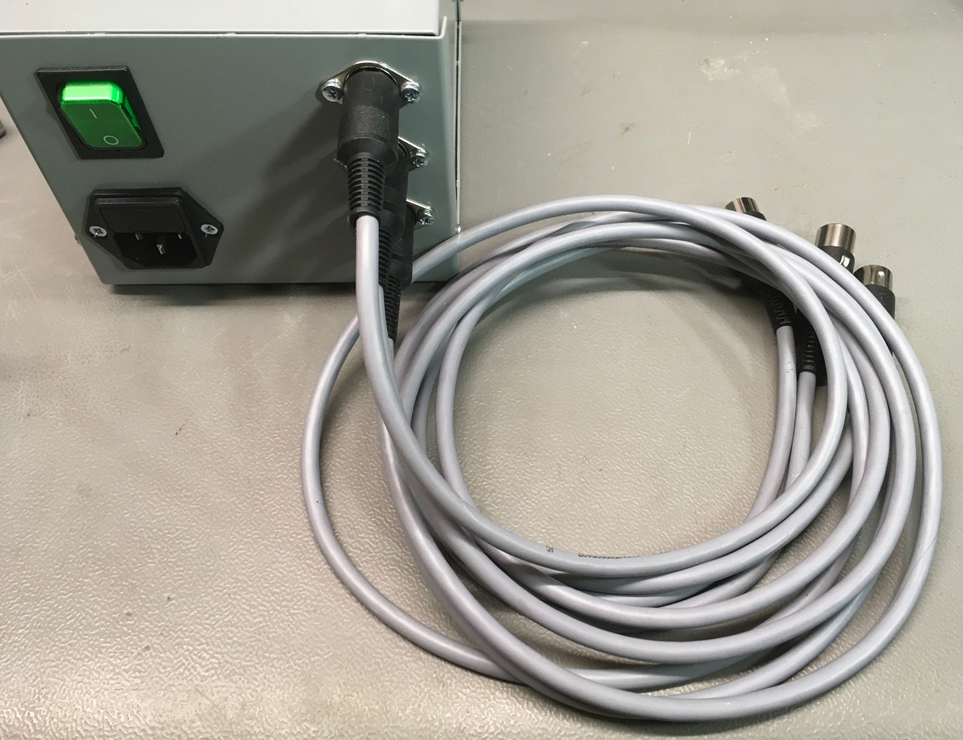

Figure 30: Back side of the Hammond case and output cables

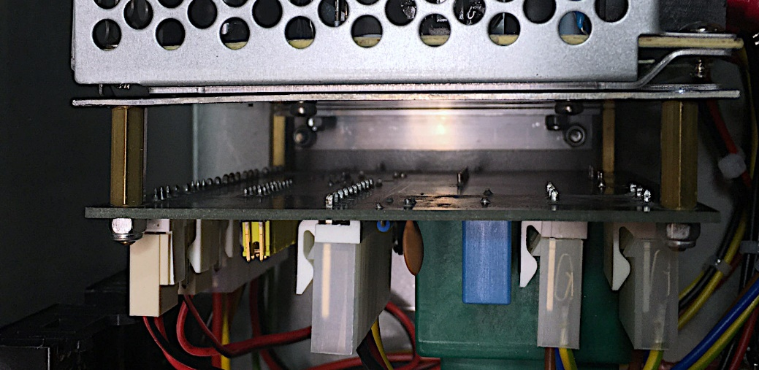

Figure 31: Mounting of the RD-50A and the PCB in the Hammond Case

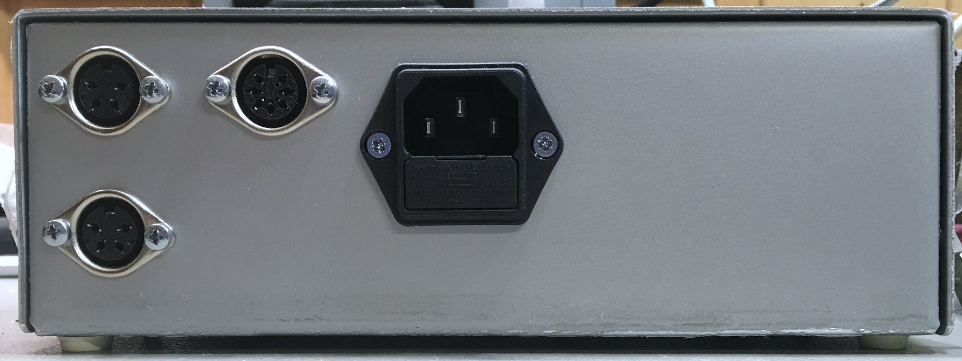

Figure 32: Back of the Teko 384 case

Figure 32 shows the back of the Teko case 384. The (illuminated) mains switch is in the front and also serves as a power indicator.

# Further Thoughts

The panel meters are not really required. In case, they are not used, the 5V on the voltage connector of the panel meter can be connected to a USB A jack, which then can power accessories like the RetroTINK video converter. This way, one more power supply can be saved. It was not tested to drive a PI1541 with it, which might require a bit more current.

Since many possible externals PSUs have a wide range input – the RD-50A is capable of 88VAC to 264VAC – the Rev. 1 of the PSU Combi will have an option for a transformer that allows 115V/230V switching.

# Revision History

## Rev. 0

* Fully functional prototype

## Rev. 0 → Rev. 1

* 115V/230V transformer option (TR1)
* Removed the useless connectors for the current measurement
* Used the free space to widen the traces

## Rev. 1 → Rev. 2

* The footprint for the expansion connector was modified, so that solder bridges can be used in case the expansion is not used.
* Added J10 as a connector for +5V. This can be used as auxiliary power (e.g. a HDMI converter) on a barrel connector or USB connector.